ARC 5558 Customer Order Portal

The ARC 5558 Customer Order Portal is a modification to the standard shipping dashboard located at Shipping & Receiving > View > Shipping Dashboard. The purpose of this dashboard is to be a live update of order information for a customer. Through the maintenance program, the user can generate a batch file that will launch the dashboard for just that customer without launching the entire GS Menu.

Shipping & Receiving > Administration > Customer Order Portal Maintenance [5558]

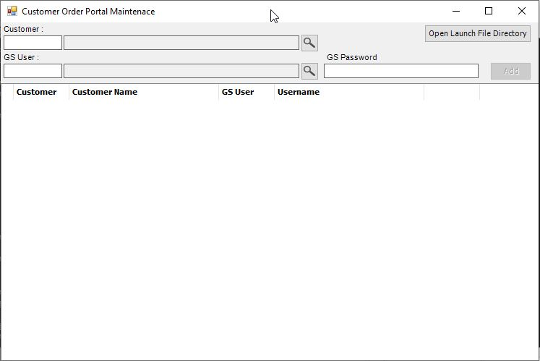

The maintenance screen is where you associate the customer to a GS user and generate the batch file for them to log in to the dashboard. First select the customer that will be viewing the dashboard. Then select a GS User to associate them with. This will be the user that they log in to the dashboard with. The password for that user will need to be entered as well.

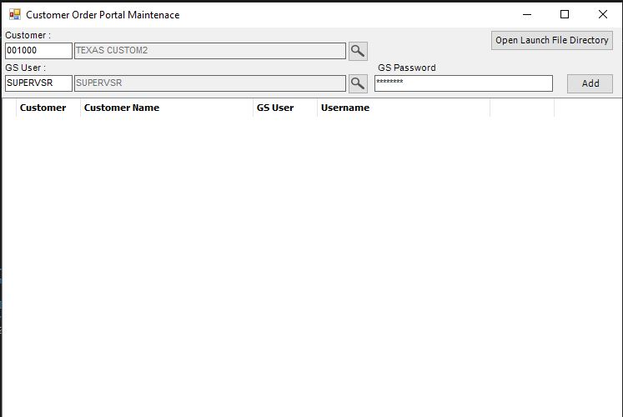

Click Add when ready to add the association. If everything entered is correct, the association should show up in the grid.

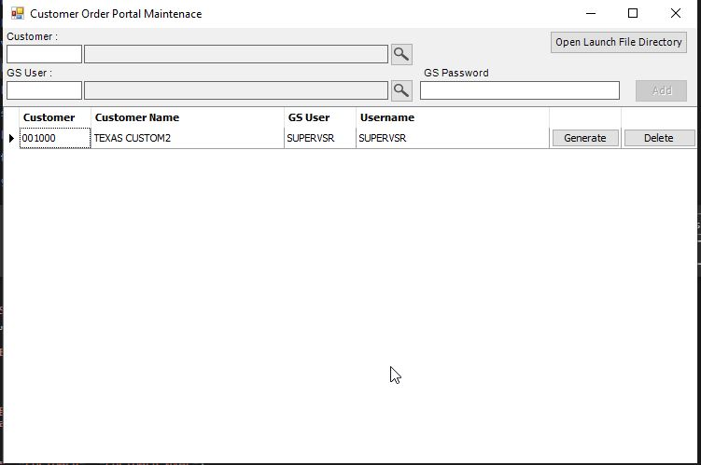

To delete the record, click delete. To create the batch file that will launch the dashboard for that customer, click the generate button on the record you want to create it for.

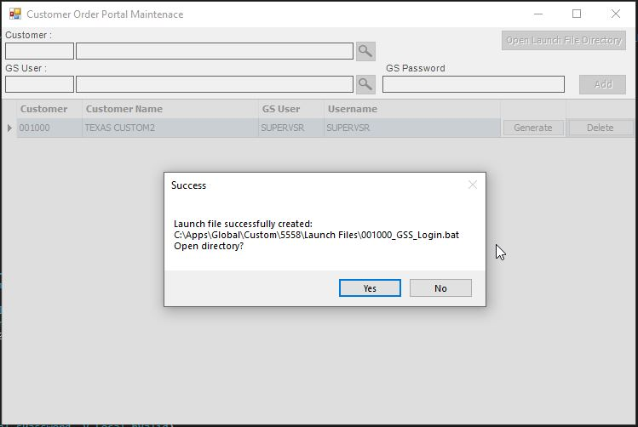

A success message will pop up with the file path of the launch file. Click yes to be taken to it. You can also click the Open Launch File Directory button on the maintenance screen to be taken there.

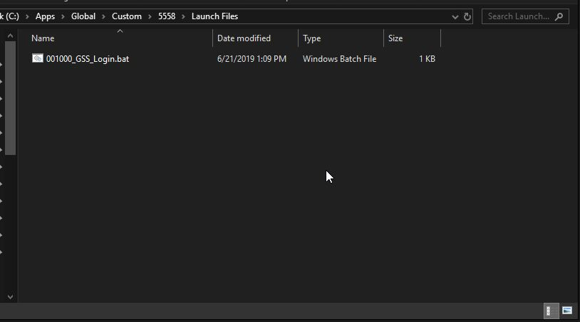

The batch files will be put in your Global\Custom\5558\Launch Files directory. The filename will include the Customer Code (001000 in this case).

There will also be a file created in Global\Custom\5558\Directive Files. These are required for launching. Do not delete, move, or modify them.

You can copy and paste the batch file to any location that has access to your Global Shop network, and as long as the Global Shop components are installed on that computer, the user will be able to launch the dashboard by running that batch file.

Shipping & Receiving > View > Customer Order Portal [5558]

When launching the dashboard normally (as a user not associated with a customer), the functionality will be the same as the standard shipping dashboard with a few additions.

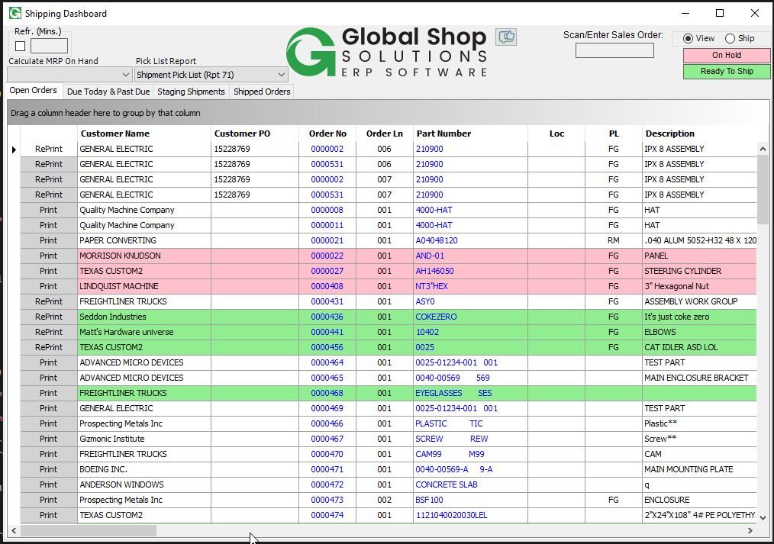

The dashboard now pulls in the Order Due Date as the Original Due Date, the Order Line Due date as the New Ship Date, and has a Days late column, calculated as today’s date – original due date.

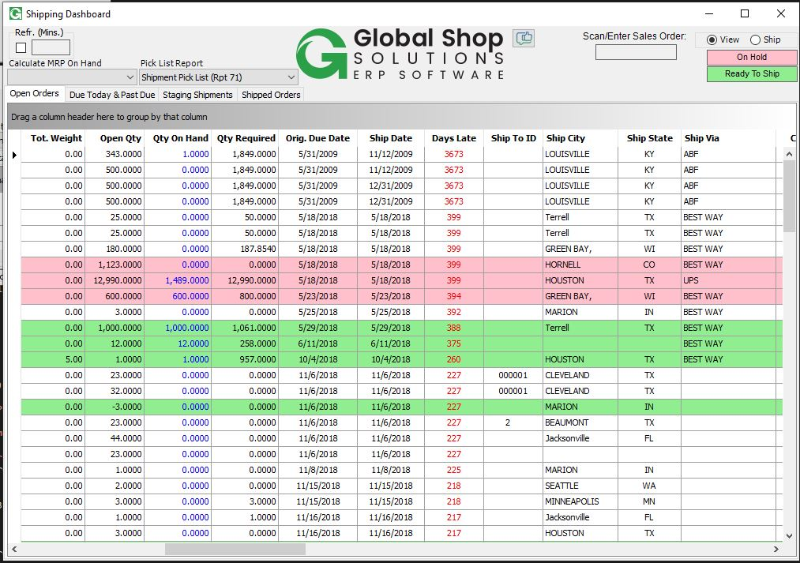

There are also four other additional columns. Acero Notes, Last Acero Update, Customer Notes, and Last Customer Update. The Acero notes are only modifiable by the company (Acero), and the Customer Notes are only modifiable by the Customer. The respective Last Update columns will populate with the date updated when one of the notes is changed. 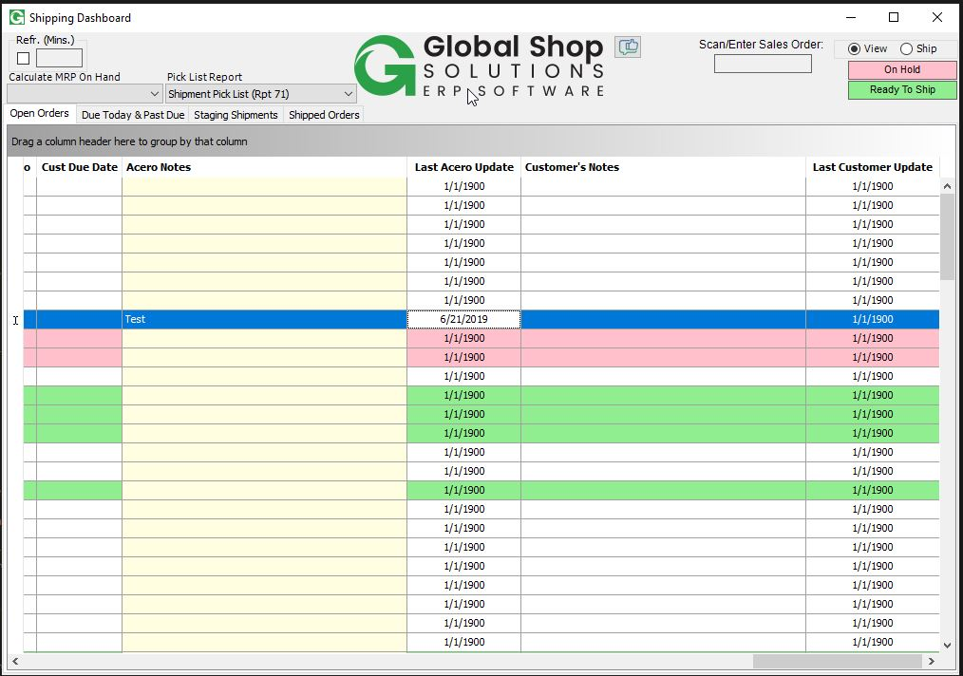

When a user associated with a customer loads the dashboard from the batch file generated in the maintenance script, only their orders will load, and additional features on the dashboard will be disabled. Also several columns will be hidden to them by default.

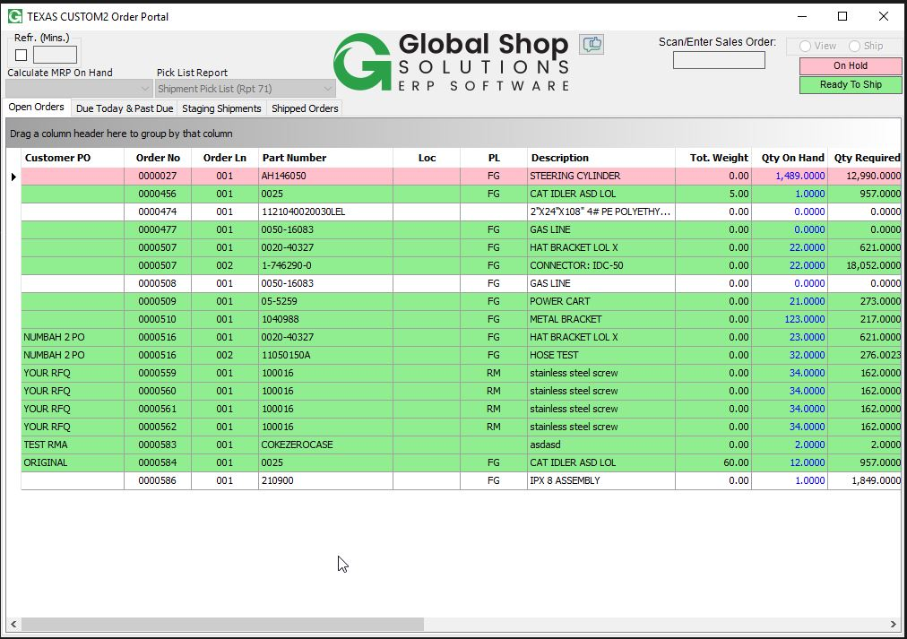

The dashboard will close itself after 30 minutes of inactivity if launched by a customer.

